Jesus said-We are engaged
7.10.26
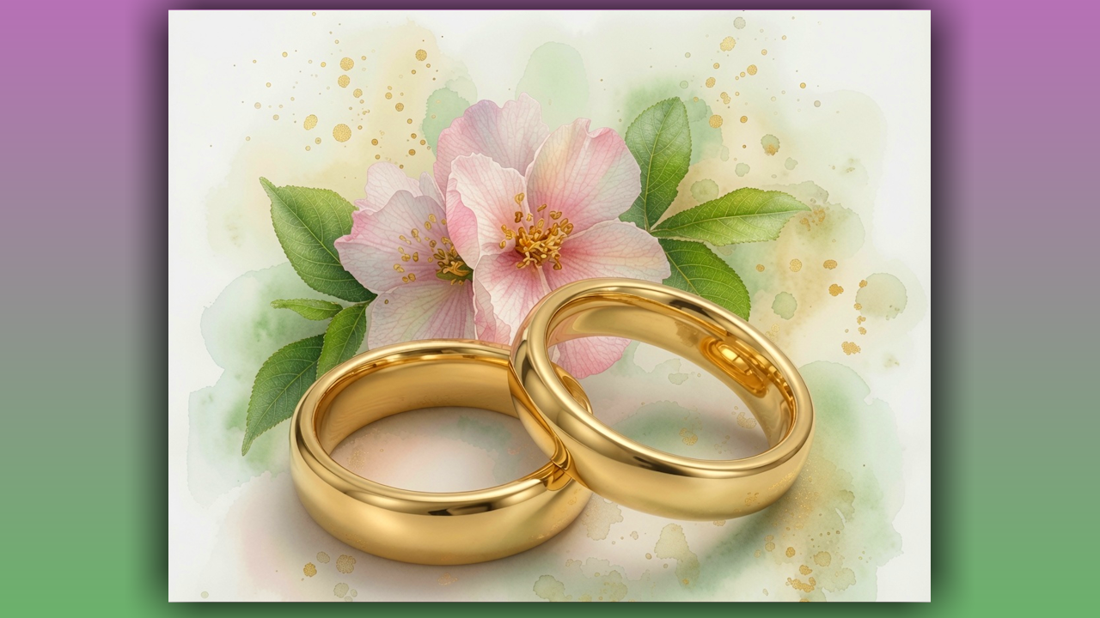

Dear family, your prayers are amazing and powerful. We are back in heaven with Jesus. May this sweet discourse with our Savior bring you great peace and security.

Your prayers are powerful as we once again move deeper into our bridegroom's arms. Amen. I came into prayer wanting to receive more confirmations that we are on the right track.
Jesus did not keep me waiting. I heard His voice immediately.

“You were dancing with me”, He said.

“I want you to tell everyone about it and that I will also dance with them. Worship is warfare and the place of the deepest blessings, although please don't worship me for what you can get but for what you can give.
Believe it or not, I need your love and adoration. I need that from you, my creatures. Enter into that coveted place in my heart where time stands still and I remain with you forever.”

He continued,

“ Beloved, you are on the right track and pleasing to me, very pleasing. Now all that is left is your music, which I want to do something very special with. Do not doubt. When you doubt, you play right into the enemy's hands. That's all it takes to threaten the good direction I give you. You not doubt, just flow with me. “

Lord, that isn't so easy when I feel like I've fallen into a deception. Jesus replied,

“And who told you that you were deceived?”

Well, Lord, I just assumed it.
I assumed I'd make a mistake in discernment, and I had gone to the Bible Promises and I got God's protection, which means I wasn't deceived. God was protecting me, and I said, Wow, I don't know how to apply that. Please turn my confusion into clarity.
I had asked about something and not gotten a confirmation, so I assumed that I missed it.

“I will.”
He answered gently, “Thank you. He continued,

You are dealing with the things that need dealing with, but now let's focus on love. My dear ones, you turn many fears over and over again in your minds. It truly is a stream of toxic water flowing from degenerate, badly corrupted fallen spirits. Instead, when you come into worship, sweep all accusatory thoughts totally out of your mind and enter into worship with me. I cannot even begin to tell you how many times I wanted to dance with you, but you must use strong self-control or your mind will be captivated with the news and the many manipulative stories they tell. Yes, there is a place where you must consider those things and bring them to me in fervent prayer. But for the most part, I want to celebrate our engagement and what that means for your future, a glorious future in heaven with me. In heaven, you will be given a complete wardrobe, clothing you will wear on a variety of publications. I know that has no meaning to you now, wearing your habit, but in heaven you will most certainly need a change of clothes. In your homeland, everything will be supplied. Just think of what you want and it will be given you.”

Lord, what if all I want is you and the rest in your arms?

“Then you shall have it.” He replied, Lord, I cannot imagine anything else that I want.

“There will be prayer and worship events,” he continued. “Heaven is a dynamic place, my bride. There is so much going on, so many people to meet and share your life and worship with. They already know you.They've already seen and they are anxious to show you their love and share with you their own adventures and how they came to be there. And you will meet all your relatives all the way back to Noah and come to understand the history of your DNA. This will be a true revelation to you and so much will be explained and come into sharp focus. You are going to love this time and I will be there with you, loving it as well. You will never again be alone unless you choose to be. Every wound, my beloved, will be completely healed so you will not have that oppression affecting your personality or interactions. You will very much love that as well. You will be in sublime peace. Dwell on that, my loved ones, all of you. You will be in sublime peace in heaven with me.”

And that was the end of his message.

